**I. Present simple (Thì hiện tại đơn)**

**a. Form**

|  |  |
| --- | --- |
|  | **ĐỘNG TỪ THƯỜNG** |
| **(+)** | I, you, we, they + V-inf(động từ giữ nguyên)  He, she, it + V(s/es) |
| **(-)** | I, you, we, they + don’t + V-inf  He, she, it + doesn’t + V-inf |
| **(?)** | Do + I, you, we, they + V-inf?  Does + he, she, it + V-inf? |

**1.ĐỘNG TỪ BE**

|  |
| --- |
| I + am  You, we, they + are  He, she, it + is |
| I am not  You, we, they + aren’t  He, she, it + isn’t |
| Am + I...?  Are + you, we, they ...?  Is + he, she, it...? |

**b. Usage**

* Thì hiện tại đơn dùng để diễn tả một thói quen hoặc một hành động có tính lặp đi lặp lại ở hiện tại.

VD: She often goes to school at seven o’clock in the morning,

*(Cô ấy thường đi học vào 7giờ sáng.)*

* Thì hiện tại đơn dùng để diễn tả một chân lý hoặc một sự thật hiển nhiên.

VD: The sun rises in the East and sets in the West.

*(Mặt trời mọc đằng đông và lặn đằng Tây.)*

* Dùng để chỉ một sự việc sẽ xảy ra trong tương lai theo thời gian biểu hoặc lịch trình.

VD: The news programme starts at seven p.m.

*(Chương trình thời sự bắt đầu vào lúc 7 giờ tối.)*

**CHÚ Ý :How to add “s/es”to verbs :Cách thêm “s/es**

❖ Thông thường ta thêm “s” vào sau các động từ.

listen🡒listens play 🡒plays

❖ Những động từ tận cùng bằng: -s; -sh; -ch; -z; -x; -o ta thêm “es”.

miss🡒misses watch 🡒watches mix 🡒mixes

wash🡒 washes buzz 🡒buzzes go 🡒 goes

❖ Những động từ tận cùng là “y”:

+ Nếu trước “y” là một nguyên âm (a, e, i, o, u) - ta giữ nguyên “y” + “s”

play🡒plays buy🡒buys pay🡒pays

+Nếu trước “y” là một phụ âm - ta đổi “y” thành “i” + “es”

fly🡒flies cry🡒cries fry🡒fries

**2. Adverbs of frequency (Trạng từ chỉ tần xuất)**

**Usage**

1. Trạng từ tần suất được sử dụng để diễn tả mức độ thường xuyên của một hành động hay một thói quen. (luôn luôn, thường xuyên, thỉnh thoảng, không bao giờ,…)

|  |  |
| --- | --- |
| **Trạng từ chỉ tần suất** | **Ý nghĩa** |
| Always | Luôn luôn (ở mức 100%) |
| Usually | Thường xuyên (mức 90%) |
| Often | Thường thường (mức 70%) |
| Sometimes | Đôi khi, đôi lúc (mức 50%) |
| Never | Không bao giờ (mức 0%) |

* She always gets up late. (Cô ấy luôn luôn thức dậy trễ.)
* She often goes to the park. (Cô ấy thường đi công viên.)
* She sometimes eats at home. (Cô ấy thỉnh thoảng mới ăn ở nhà.)
* She seldom goes picnic. (Cô ấy hiếm khi đi dã ngoại.)
* She never plays badminton. (Cô ấy không bao giờ chơi tennis.)

**VỊ TRÍ CỦA TRẠNG TỪ**

1. **Đứng sau động từ “tobe”**

Ví dụ: I am never late for school. (Tôi không bao giờ đi học trễ)

2. **Đứng trước động từ chính và đứng sau chủ ngữ**

Ví dụ: He sometimes wash his car. (Anh ta thỉnh thoảng mới rửa xe)

3.**Đứng giữa trợ động từ và động từ chính trong câu**

Ví dụ:

– I have never been abroad. (Tôi chưa bao giờ đi nước ngoài)

– You should usually do your homework before going to school. (Bạn nên làm bài tập về nhà trước khi đến lớp)

**Task 1. Put the verbs in brackets into the Present Simple.**

1. She (**walk)**___________ to school every morning.
2. They (**learn**) ___________________ how to use the lawnmower in their free time.
3. Linda (**go**) ______________to the supermarket to buy some sugar.
4. Sometimes I (**feel**) _________________________ really lazy to do anything.
5. Phong and I (**study**) _________________________ English in my room.
6. I often (**have**) ____________________ breakfast at 7 am at home.
7. She (**do)**_________________ aerobics every morning to keep fit.
8. Nga (**like**) __________________playing basketball very much.
9. What time you (**have**) _____________________lunch every day?
10. She (**not** **have**) __________________ any pen, so I lend her one.

**11.** They ______________ (**play**) football and basketball at school.

**12.** My father ______________ (**read**) the newspaper every morning.

**13.** We ______________ (**have)** English, Maths and Science on Monday.

**14**. She never ______________ (**do**) her homework.

**15.** I ______________ (**go**) swimming twice a week.

**16**. Cars ______________ (**be**) more expensive than motorbikes.

**17.** Jane always ______________ (**have**) breakfast at 6 o’clock.

**18** He usually ______________ (**watch**) TV after dinner.

**19**. London ______________ (**be**) a very big country.

**20**. I _____________ (**be**) a student and my parents ___________ (**be**) teachers.

**Task 2.Read the sentences. Underline the correct words.**

**1.** My mother **make/ makes** breakfast.  
**2.** My sister **do/ does** the laundry.  
**3. My brother do/ does the dishes.  
4. My father make/ makes the bed.  
5. I clean/ cleans the kitchen.  
6. Lily do/ does the shopping.  
7. Jack and Paul make/ makes dinner together.  
8. Lily's dad clean/ cleans the bathroom.  
9. Their mom do/ does the most housework.**

**10. My brother play/ plays football very well.**

**11. I (goes** **go**) swimming twice a week.

**12** Cars (**is/are/**) more expensive than motorbikes.

**13.** Jane always (**have/has**) breakfast at 6 o’clock.

**14** He usually (**watch waches**) TV after dinner.

**15**. London (**is/are**) a very big country.

…………………………………………………………………………………………………

II. **Present continuous (Thì hiện tại tiếp diễn)**

**a. Form**

|  |  |
| --- | --- |
| **(+)** | I + am + V-ing.  You, we, they + are + V-ing.  He, she, it + is + V-ing. |
| **(-)** | I am not + V-ing.  You, we, they + aren’t + V-ing.  He, she, it + isn’t + V-ing. |
| **(?)** | Am + I + V-ing?  Are + you, we, they + V-ing?  Is + he, she, it + V-ing? |

**b. Usage**

* Thì hiện tại tiếp diễn diễn tả một hành động đang diễn ra tại thời điểm nói.

VD: My mother is cooking in the kitchen now. *(Hiện tại mẹ tôi đang nấu ăntrong bếp.)*

❖ Thì hiện tại tiếp diễn diễn tả một hành động hoặc sự việc đang diễn ra xung quanh thời điểm nói.

VD: Linda is quite busy these days. She’s doing the English project for her school. (Linda is in a restaurant with her friend now.)

(Linda dạo này rất bận. Cô ấy đang làm dự án tiếng Anh cho trường của cô ấy.) *(Hiện tại Linda đang ngồi trong nhà hàng với bạn cô ấy.)*

* Thì hiện tại tiếp diễn có thể diễn tả một hành động sắp xảy ra trong tương lai gần (điều này đã được lên kế hoạch).

VD: He is going to Paris. *(Anh ấy định đi Paris.)*

* Thì hiện tại tiếp diễn diễn tả một hành động thường xuyên xảy ra lặp đi lặp lại gây sự bực mình hay khó chịu cho người nói. Cách dùng này được dùng với trạng từ “always, continually”.

VD: Tony is careless. He is always losing his keys. *(Tom thì bất cẩn.Anh lấy luôn làm mất chìa khoá.)*

**c. Signals**

Các trạng từ hay gặp: *now, at the present, at the moment, at this time*(bây giờ, lúc này)

Các động từ: *Look!* (Nhìn kìa), *Listen*(Nghe này); *Becareful!*(Cẩn thận);*Hurry up!* (Nhanh lên)

**d. How to add“ing” after verbs**

* Thông thường nhất, ta thêm đuôi -ing vào sau các động từ.

read🡒reading go 🡒going

* Khi động từ kết thúc bằng “e”, ta bỏ “e” trước khi thêm “ing”.

have🡒having make 🡒making

❖ Khi động từ kết thúc bằng “ee”, ta thêm ing mà không bỏ “e”.

see🡒seeing agree 🡒agreeing

❖ Khi động từ kết thúc bằng “ie” ta đổi “ie”->“y” rồi thèm “ing”.

lie🡒lying die 🡒dying

❖ Khi âm tiết cuối của động từ mang trọng âm và có chứa 1 nguyên âm + 1 phụ âm, ta gấp đôi phụ âm cuối rồi thêm “ing”.

run🡒running permit 🡒permitting

**e. Note**

Chúng ta không dùng thì hiện tại tiếp diễn với các động từ thuộc về nhận thức, tri giác hoặc sự sở hữu như: *be, see, hear, understand, know, like, want, feel, smell, remember, forget,*...Tasử dụng thì hiện tại đơn thay vì hiện tại tiếp diễn trong các trường hợp này.

Example

False: ~~She is being happy~~.

Correct: She is happy.

**2. MỘT SỐ ĐỘNG TỪ KHÔNG chia ở thì hiện tại tiếp diễn:**

|  |  |  |
| --- | --- | --- |
| 1. Want  2. Like  3. Love  4. Prefer  5. Need  6.  Believe  7. Contain  8. Taste | 9. Suppose  10. Remember  11. Realize  12. Understand  13. Depend  14.  Seem  15. Know  16. Belong | 17. Hope  18. Forget  19. Hate  20. Wish  21. Mean  22. Lack  23. Appear  24. Sound |

**Task 1.Verbs form:**

I. **Complete the sentences with forms of *be* or *have*.**

1. She ____________ long blond hair.

2. He ____________ green eyes. They look so nice.

3. He ____________ short blond hair.

4. His eyes ____________ black and quite large.

5. Her eyes’ color ____________ green. It is brown.

6. She ____________ in good-shape. She is a little thin.

7. (she) ____________ straight black hair? - Yes.

8. My uncle ____________ medium-height. He is just a little taller than me.

9. What (John) ____________ on his nose? - Glasses. He is reading a book.

10. (Mai) ____________ short black hair or long brown hair?

11. His mouth is small and he ____________ green eyes.

12. George ____________ short hair like most of men. His hair is quite long and smooth.

13. Miranda’s parents have brown eyes, but she doesn’t. Her eyes ____________ blue.

14. Which is his complexion’s color? (it) ____________ tanned?

15. My grandfather ____________ a moustache. He has got a beard

DANH TỪ ĐẾM ĐƯỢC VÀ KHÔNG ĐẾM ĐƯỢC

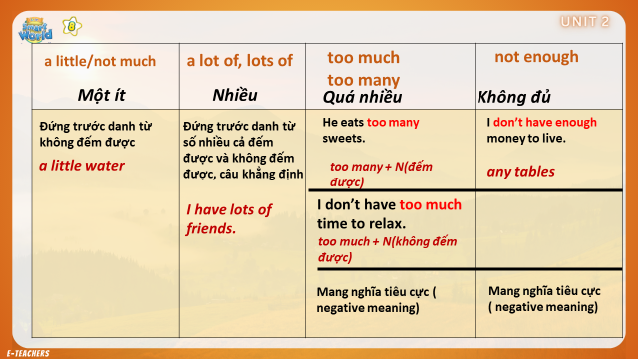

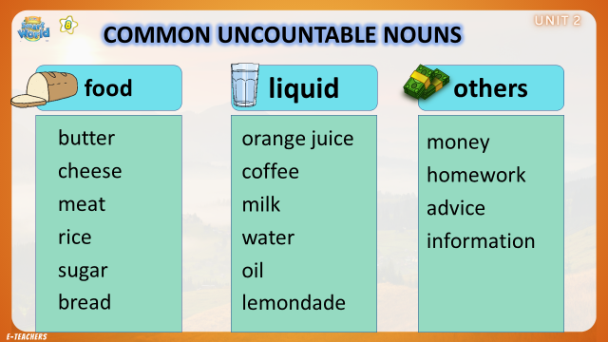

IV .ĐỘNG TỪ CHỈ SỞ THÍCH (LIKE,/ENJOY/ HATE/ DISLIKE/

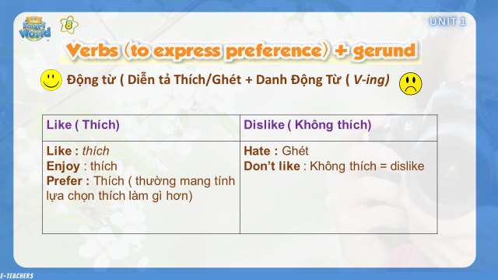

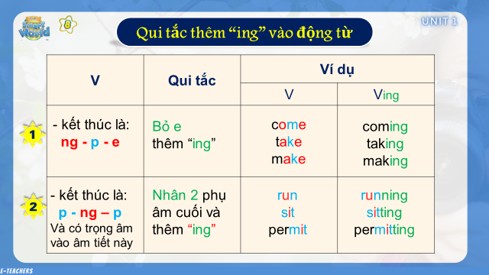

**Tiếng Anh 8 – i-LEARN SMART WORLD**

***UNIT 2 TEST***

**I. PRONUNCIATION**

***A. Choose the word whose underlined part differs from the other three in pronunciation in each of the following questions.***

1. A. church B. chemistry C. lunch D. cheese

2. A. Christmas B. armchair C. teacher D. chocolate

3. A. school B. headache C. character D. children

***B. Choose the word whose primary stress is NOT placed on the first syllable.***

4. A. never B. country C. prefer D. weather

***C. Choose the word whose primary stress is NOT placed on the second syllable.***

5. A. another B. flower C. computer D. because

**II. USE OF ENGLISH**

***Choose the best option (A, B, C or D) to complete each of the following questions.***

6. It’s _____________ to have a walk along the rice fields early in the morning.

A. relaxed B. relaxes C. relax D. relaxing

7. People in the countryside prefer __________ the rice they grow in their fields.

A. to eat B. ate C. eat D. eats

8. Lisa’s hometown is about 250 kilometers ____________ Ho Chi Minh city.

A. for B. from C. to D. away

9. Jane’s mom: People in the countryside often have a healthy lifestyle. - Jane: __________.

A. Really? I love the countryside, too. B. I disagree. They don’t have good doctors.

C. I agree. They do more physical activities. D. I agree. They usually eat fruit and fish.

10. Liz: __________ does John play spinning tops? - Ben: Not often, about once or twice a month.

A. How long B. How far C. When D. How often

11. One of the ____________ festivals in the countryside is Mid-Autumn festival.

A. traditional B. tradition C. traditionally D. traditions

12. My sister seldom plays badminton after work, she prefers __________ in the nearby river.

A. swims B. to swim C. to swimming D. swam

13. It’s very interesting to _________ activities like a lantern parade.

A. take part B. participating C. participate D. take part in

14. Tom: ___________________? Peter: Good idea. It’s the best place to play shuttlecock.

A. What are you going to do this afternoon? B. How about going to the park after school?

C. Do you like to play shuttlecock? D. How often do you play shuttlecock?

15. There’s not much _________ in the countryside. People usually enjoy the fresh air there.

A. noise B. water C. pollution D. air

16. Some folk games in the countryside can keep children away ________ their cell phones.

A. to B. from C. for D. with

17. Most students in my class are hard-working. They ________ finish all their homework before they come to class.

A. always B. sometimes C. rarely D. never

**III. WORD FORMATION**

***A. Write the correct compound of the words in brackets.***

18. Russia is known as one of the biggest ***_____________*** in the world. (COUNTRYSIDE)

***B. Write the correct form of the words in brackets.***

19. No one is bringing raincoats or umbrellas. Rainy weather at this time of year is very ***_____________***. (USUALLY)

20. They ***_____________*** the time and place of the Hiền Lương Village Tết festival last night. (ANNOUNCEMENT)

**IV. ERROR RECOGNITION**

***Find the underlined part that needs correction in each of the following questions.***

21. We’d like to announce the village festival will take place on January 21st to February 2nd. A B C D

22. All the children are interested in the animal perform at the festival.

A B C D

**V. READING**

***Read the text and choose the best answer, A, B, C, or D, for each question****.*

|  |
| --- |
| **Milford Nature Festival!**  **The event for all the family!**  Come and celebrate the first day of spring on Saturday 1st April, with:   * a flower show [at 11.00 and 2.00] * tree planting [at 11.30 and 2.30] * a nature walk [at 12.00 and 3.00]   + with information about all the flowers and trees from a plant scientist * and entertainment for all the family, including:   + tug of war [3 age groups]   + face painting for younger visitors   + competitions   The event starts at 10.00 on the grass near the west gate of South Park, opposite the Milford Sports Center. The gate opens at 9.00. You can get:   * an all-day ticket for just $10   + 10.00 to 4.00 * a half-day ticket for $6   + 10.00 to 1.00   or   * + 1.00 to 4.00   [students and under 11s = 50% discount] |

23. What does the festival celebrate?

A. The start of a month

B. The beginning of a season

C. Flowers

D. Trees

24. Where does the festival take place?

A. In South Park

B. Near South Park

C. In the Milford Sports Center

D. In Westgate

25. How much does a half-day ticket cost for a 10-year-old student?

A. $3

B. $5

C. $6

D. $10

26. What takes place in the afternoon?

A. A flower show.

B. Tree planting.

C. A nature walk.

D. All three things.

27. How long does the festival last?

A. 3 hours.

B. 4 hours.

C. 5 hours.

D. 6 hours.

**VI. LISTENING**

***Listen to a conversation between two friends. Choose the best answer, A, B, C, or D, for each question.***

28. What does the girl like about the village?

A. The sound of birds.

B. The insects.

C. The wildflowers.

D. The peace and quiet.

29. The girl

A. would like to move to the city.

B. would like to stay in the country.

C. would like to live in a large town.

D. is not sure about the best place to live.

30. The girl and the boy agree about

A. the facilities in the village.

B. the transport in the village.

C. the problems of living in a city.

D. the idea of living in a large town.

31. The boy doesn’t want to move to the city because

A. he likes his house.

B. he loves his bedroom.

C. cities are noisy and dirty.

D. city people are not friendly.

32. How is the girl getting home?

A. By car.

B. By bus.

C. On foot.

D. On her bicycle.

**VII. WRITING**

***A. Rewrite the following sentences without changing their meaning. Use the given word(s) if any.***

33. The food and drink at the outdoor dinner tonight are free for children under 11. (PAY)

→ Children ______________________________________________________________

34. My mother hates noisy parties and crowded places. (NEVER)

→ My mother ____________________________________________________________

35. Julie doesn’t usually take part in traditional festivals because she works in the city.

→ Julie works ____________________________________________________________

36. Jack sometimes rides his bike around the countryside to enjoy some fresh air.

→ Jack sometimes goes _____________________________________________________

***B. Use the given words or phrases to make complete sentences.***

37. There / a lot / outdoor / activity / for / children / the countryside / .

→ ______________________________________________________________________

38. Most / big / city / world / seriously / polluted / .

→ ______________________________________________________________________

***C. Put the words in the correct order to make correct sentences.***

39. to play / games / folk / students / like / young / Most / .

→ ______________________________________________________________________

40. do / often / they / how / hometown / visit / their / ?

→ ______________________________________________________________________

***\*\*\*\*\* THE END \*\*\*\*\****