**I. Passive forms**

- explains some more about the passive form:

Active: S + V + O...

Passive: S(o) + be + Past participle... (by + N)

Present Simple: S + am/ is/ are + past participle...

Past Simple: S + was/ were + past participle...

Future Simple: S + will/ shall be + past participle...

Present Perfect: S + have/ has been + past participle...

1. a lot of rice.
2. This is a machine which is used to wash clothes.

**II. Reported speech**

**1. CÂU TRẦN THUẬT**

- sets the scene: “Yesterday Lan’s grandmother, Mrs Thu, needed a plumber. A man came to her door and said *I’m a plumber.*”

- writes the quoted speech on the board

He said “I’m a plumber.”

- asks students to report what the man said and writes it on the board

Model sentences: Reported speech

He said he was a plumber.

Reported/ indirect speech

- asks Ss to pay attention to changes in:

***\*Tenses:***

|  |  |
| --- | --- |
| Quoted speech | Reported speech |
| Present Simple  Will  Must  can | Past Simple  Would  Had to  could |

***\*Adverds of place/ time and pronouns***

this that

now then

here there

ago before

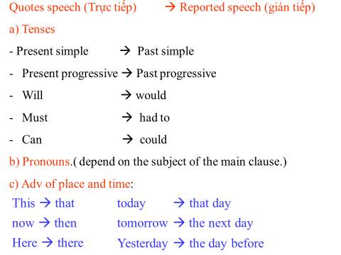

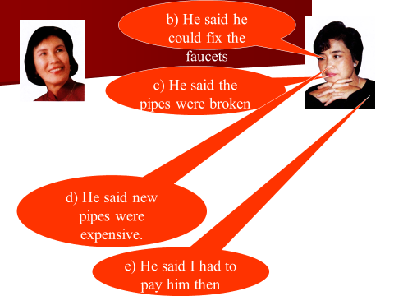

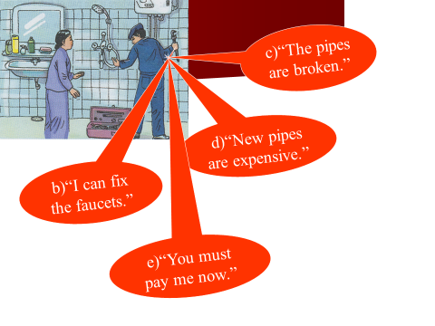

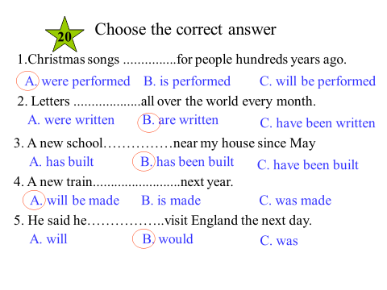2

2. CÂU HỎI ĐOÁN (YES /NO QUESTION)

*Yes – No Questions ( câu hỏi xác nhận có – không ):*

S + asked/inquired/wondered/want to know + If/Whether + S2 + V ( lùi thì)..

Ex: “ Do you like the film ?” Nam asked

- Nam asked if/ whether I liked the film.

“ Are you a student ?” She wanted to know

- She wanted to know if / whether I was a student**.**

*3.. Wh – Questions ( Câu hỏi có từ để hỏi ) :*

S + asked/inquired/wondered/want to know + Wh -qs + S2 + V ( lùi thì)…

Ex: “ What is your name?” She asked me

- She asked me what my name was

“ Why don’t you go to school this morning ?” mother asked me

- Mother wanted to know why I didn’t go to school that morning.

“ Who put salt in my coffee?” he asked

- He asked who had put salt in his coffee

* Note: Trong trường hợp câu trực tiếp có cả câu trần thuật lẫn câu hỏi thì khi đổi sang câu gián tiếp, phần nào vẫn cứ đổi theo phần ấy.

Ex: “ I have left my watch at home. Can you tell me the time?’ he said

- He said ( that ) he had left his watch at home and he asked if I could

**III.** Conditional sentence

1. type 1: (Câu điều kiện loại 1):

|  |
| --- |
| If clause Main clause  (simple present ) (will + V1)  If + S +V(s,es) S +will + Vo |

Câu điều kiện loại 1 ở hiện tại, chỉ 1 khả năng có thể có được ở hiện tại hoặc tương lai.

Ex: A: Oh, I’ve lost my keys. Have you seen them?

B: No, I haven’t but if I find them, I will tell you

*(Việc tìm ra chìa khoá là một khả năng có thể có thực)*

❖ Câu điều kiện loại 1 với thể mệnh lệnh: Ta có thể dùng câu mệnh lệnh để thay cho mệnh đề IF trong câu điều kiện loại 1.

Ex: Go with me and I will show you my new car.

= If you go with me and I will show you my new car.

2 type 2: (Câu điều kiện loại ):

|  |
| --- |
| If clause Main clause  (simple past )to be luôn là Were với các ngôi (would + Vo) |

If + S + Ved/were ……….. S +Would +Vo

* Diễn tả hành động không có thật ở hiện tại

*Unless = If not