**I. Passive forms**

- explains some more about the passive form:

Active: S + V + O...

Passive: S(o) + be + Past participle... (by + N)

Present Simple: S + am/ is/ are + past participle...

Past Simple: S + was/ were + past participle...

Future Simple: S + will/ shall be + past participle...

Present Perfect: S + have/ has been + past participle...

**II. Compound words**

- elicits the model from students

a rice - cooking festival

a water - fetching competition

a fire - making contest

noun V-ing

compound adjective Noun

Concept check

Form: a noun + V-ing compound word

Use: to be used as an adjective

IV. Compound adjective

1. It is a contest in which participants have to make fire.
2. It is a festival in which people have their bulls fight against each other.
3. The United States has a big industry that makes cars.
4. Last week Tran Hung Dao School held a contest in which students arranged flowers as attractively as they could.
5. Viet Nam is a country which exports a lot of rice.
6. This is a machine which is used to wash clothes.

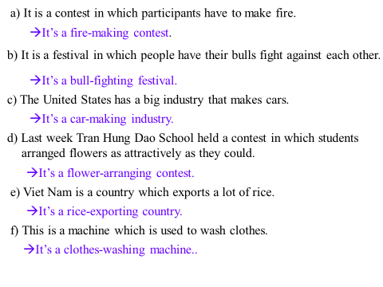

**III. Reported speech**

- sets the scene: “Yesterday Lan’s grandmother, Mrs Thu, needed a plumber. A man came to her door and said *I’m a plumber.*”

- writes the quoted speech on the board

He said “I’m a plumber.”

- asks students to report what the man said and writes it on the board

Model sentences: Reported speech

He said he was a plumber.

Reported/ indirect speech

- asks Ss to pay attention to changes in:

***\*Tenses:***

|  |  |
| --- | --- |
| Quoted speech | Reported speech |
| Present Simple  Will  Must  can | Past Simple  Would  Had to  could |

***\*Adverds of place/ time and pronouns***

this that

now then

here there

ago before

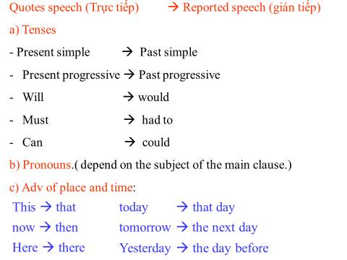

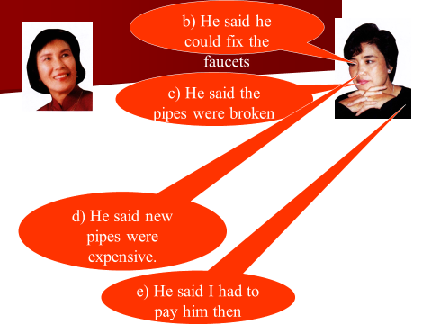

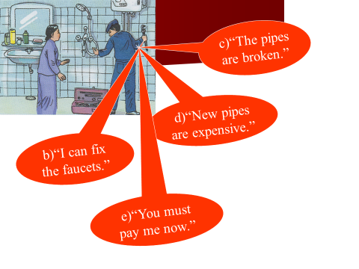

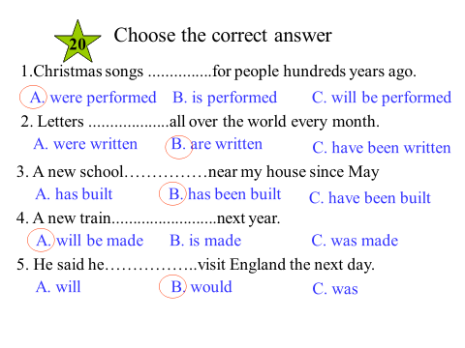

***LỚP 8***

**Part I.** LISTENING. (2,5pts)

Ex1. Listen and dicide if the sentences are true(T) or false (F)

1. Mr. Robinson: Go to the flower market to buy some apricots ………..
2. Liz Go to the market to buy some candies
3. and a packet of dried watermelon seeds …………
4. Mrs.Robinson: Go to Mrs. Nga’s house to

learn how to make spring rolls ………………

Ex2: Listen again and fill in blank with suitable word

1. .Mrs. Robinson wants _________________ to go to the __________________.

5.Mrs. Robinson wants Liz to buy a packet of ____________________.

6.Mrs. Robinson wants some marigolds because they are ______________

7.Mrs. Robinson is asking Mrs. Nga how to __________________ spring rolls.

**Part II. LANGUAGE FOCUS ( 2,5 pts)**

**I. Choose the word that has the underlined part pronounced differently from the others.**

|  |  |  |  |
| --- | --- | --- | --- |
| 1.A. ***ch***aracter | B. ***ch***emical | C. kit***ch***en | D. ***Ch***ristmas |
| 2.A. comm***e***rcial | B. g***e***nerous | C. d***e***monstrate | D. ***e***xhibition |
| 3.A. **s**ize | B. **s**ure | C. **s**erve | D. **s**ound |
| 4.A. descr**i**be | B. k**i**ss | C. g**i**ve | D. reflex**i**ve |

**II. Choose the most suitable answer to complete the sentences.**

1.Would you mind ………….the door

A opening B.open C.Opened D.opens

2. The only wonder you can still ………………..today is the pyramid of Cheops.

A. look B. see C. watch D. peep

3. I don’t know how ……….. ............. volleyball.

A. to play B. play C. playing D. plays

4. She asked me ……………….I learned English well.

A. if B. whether C. did D. A & B are correct

5.I suggest ……………….rice

A. exported B export C. exporting D. exports

6. Have you have been to Phong Nha ……………….. in Viet Nam.

A. Cave B. Place C. Reef D. Bay

III.Cho dạng thích hợp của từ

1.HA LONG BAY is a famous ………………… .(ATTRACTIVE)

2.Tet is a ………………………. festival in VIET NAM (TRADITION )

**Part III Reading: (2,5 pts)**

***A. Đọc đoạn văn dưới đây rồi chọn đáp án đúng A, B, C hoặc D: (1,5 pts)***

Christmas is an important (1) ……………… in many countries around the world. One Christmas Eve in the early 1500s, some people decorated a tree and put it in the (2) ………………. place in the Latvian city of Riga. This (3)………………… spread throughout Europe, and finally came to America (4) ………………..the 1800s. In the mid 19th century, an English man wanted to send Christmas greetings to his (5) ………………. so he had someone (6) …………………a card. 40 years later, cards were a part of the Christmas tradition.

1. A. activity B. least C. festival D. less

2. A. Street B. market C. house D. church

3. A. custom B. customer C. further D. costume

4. A. at B. in C. on D. by

5. A. lend B. trend C. friends D. face

6. A. find B. mind C. like D. design

.

**B. Read the following passage and answer the questions (1.0 m).**

Nga is now living in a beautiful new house in the country. The house has a big living room and a kitchen on the first floor and four bedrooms on the second floor. The rooms are furniture, but the living room is the nicest. In the middle of the living room, there is a sofa and four armchairs. The television and stereo are between the window and the plant. There are some pictures on the wall, they make the room more beautiful. Opposite the television, there is a bookshelf with many interesting books. To the left of the house, there is a lovely garden with a lot of colorful flowers. It must be the only modern house in the district.

1. Where is Nga living now?

……………………………………………………………………………  
2. How many rooms are there in her new house ?

……………………………………………………………………………………

3. Is the kitchen the nicest room?

……………………………………………………………………………………

**II. Choose the word (a, b, c, or d) that best fits each of the blank spaces.**

I’m a student (1) _______ Bristol University. I share a house with three other students. It’s quite a (2) ______ house. We all have our own (3) _______.There is a bed, a desk, a chair, and a wardrobe in the room. It has a washbasin and a mirror in the corner, too. We all share the kitchen, the living room, and the bathroom. We sometimes have arguments about things, like when someone spends too long (4) ______ the bathroom, but we have a lot of fun, (5) ______.

1. A. in B. at C. on D. inside

2. A. tall B. old C. heavy D. big

3. A. rooms B. flats C. houses D. apartments

4. A. on B. in C. at D. over

5. A. too B. either C. neither D. a & b

**Part D. WRITING: ( 2,5pts)**

1. We export rice every year

=>Rice ……………………………………………………

2. We should travel by bike instead of motobike

=>I suggest ………………………………………………………….

3. She started teaching English in 1998

=> She has…………………………

4. We dacorate our house before Tet

=> our house ………………………

5 **“I am a teacher “** She said

=> she said she ………………………………………………………………………

**II. Use the words given to make meaningful sentences.**

**1.**I / not/ know / how / get/ there.

………………………………………………………………………………………………

She / show / me/ where/ buy / the tickets.

.```````````````````````````````````````````````````````````````````````````````````````````

3.He/ advise/ his students/ what/ do/ the contest.

……………………………………………………………………………………………

**************************************End******************************